Bamazon tracks items for sale in a variety of departments. Running the app presents the customer with a detailed list of the items for sale, their department and price. A customer chooses an item from from the table and specifies the quantity he/she would like to purchase. The program either confirms fulfillment of the order and indicates the extended order price, or indicates that there is insufficient stock to fill the order request. Here are screen shots of user interactions:

*Successfully fulfilled order*

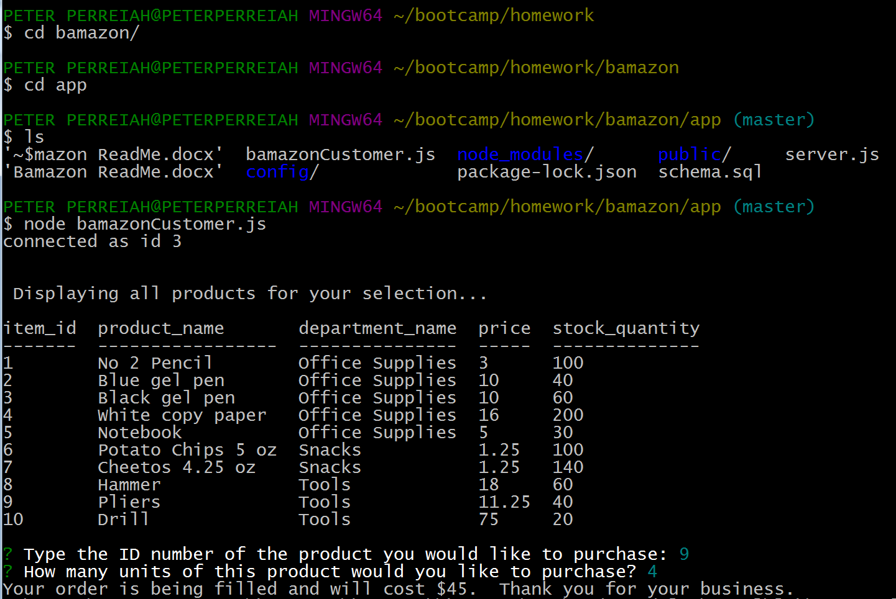

*Order request quantity exceeds stock:*

